Assignment 3 https://omega.uta.edu/~gopikrishnav/classes/2018/fall/4308_5360/assmts...

Assignment 3

Written Assignment - Game Playing & CSP

Max points:

CSE 4308: 100 (130 with EC)
CSE 5360: 100 (110 with EC)

The assignment should be submitted via Blackboard. NOTE: LATE SUBMISSIONS WILL NOT BE ACCEPTED.

Instructions

Some questions and subsections are for CSE 5360. CSE 4308 students can answer these questions for extra credit.
The answers can be typed as a document or handwritten and scanned.
Name files as assignment3_<net-id>.<format>
Accepted document format is .pdf.
If you are using Word, OpenOffice or LibreOffice, make sure to save as .pdf.
If you are using LaTEX, compile into a .pdf file.
Please do not submit .txt files.

If you are scanning handwritten documents make sure to scan it at a minimum of 600dpi and save as a .pdf or .png file. Do not insert images in word document and submit.
If there are multiple files in your submission, zip them together as assignment3_<net-id>.zip and submit the .zip file.

Problem 1

Max: [4308: 20 Points, 5360: 15 Points]


XO

O X
XO

Figure 1. A tic-tac-toe board state.

Consider the tic-tac-toe board state shown in Figure 1. Draw the full minimax search tree starting from this state, and ending in terminal nodes. Show the utility value for each terminal and non-terminal node. Also show which move the Minimax algorithm decides to play. Utility values are +1 if X wins, 0 for a tie, and -1 if O wins. Assume that X makes the next move (X is the MAX player).

Problem 2

Max: [4308: 20 Points, 5360: 15 Points]

1 of 5 9/14/2018, 08:42 PM

Assignment 3 https://omega.uta.edu/~gopikrishnav/classes/2018/fall/4308_5360/assmts...
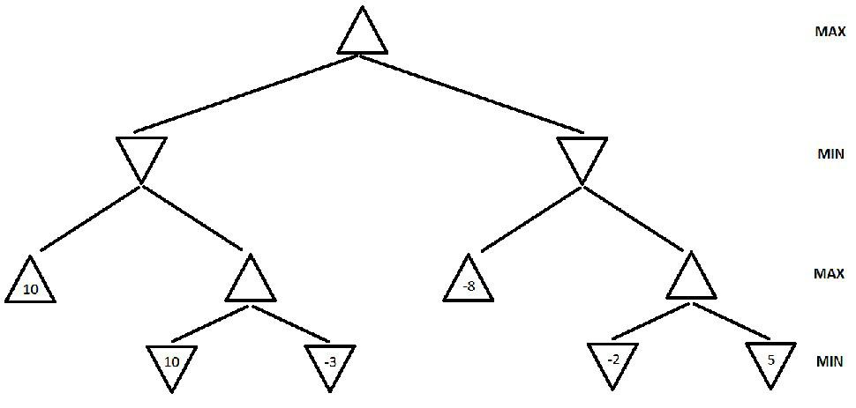

Figure 2. A game search tree.

a. (4308: 15 points, 5360: 10 points) In the game search tree of Figure 2, indicate what nodes will be pruned using alpha-beta search, and what the estimated utility values are for the rest of the nodes. Assume that, when given a choice, alpha-beta search expands nodes in a left-to-right order. Also, assume the MAX player plays first. Finally incidcate which action the Minmax algorithm will pick to exectute.

b. (4308: 5 points, 5360: 5 points) This question is also on the game search tree of Figure 2. Suppose we are given some additional knowledge about the game: the maximum utility value is 10, i.e., it is not mathematically possible for the MAX player to get an outcome greater than 10. How can this knowledge be used to further improve the efficiency of alpha-beta search? Indicate the nodes that will be pruned using this improvement. Again, assume that, when given a choice, alpha-beta search expands nodes in a left-to-right order, and that the MAX player plays first.

Problem 3

Max: [4308: 20 Points, 5360: 20 Points]
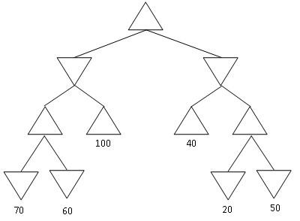

Figure 3: Yet another game search tree

Consider the MINIMAX tree above. Suppose that we are the MAX player, and we follow the MINIMAX algorithm to play a full game against an opponent. However, we do not know what algorithm the opponent uses.

Under these conditions, what is the best possible outcome of playing the full game for the MAX player? What is the worst possible outcome for the MAX player? Justify your answer.

NOTE: the question is not asking you about what MINIMAX will compute for the start node. It is asking you what is the best and worst outcome of a complete game under the assumptions stated above.

2 of 5 9/14/2018, 08:42 PM

Assignment 3 https://omega.uta.edu/~gopikrishnav/classes/2018/fall/4308_5360/assmts...

Problem 4

Max: [4308: 15 Points, 5360: 10 Points]
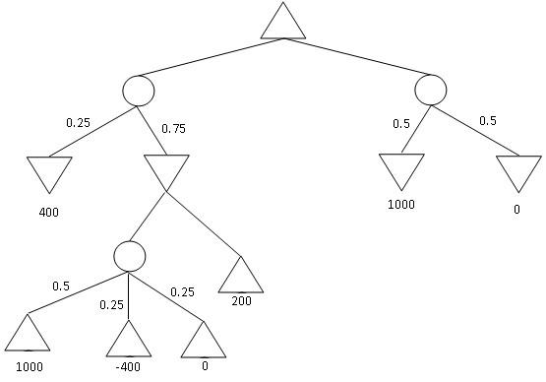

Figure 4: An Expectiminmax tree.

Find the value of every non-terminal node in the expectiminmax tree given above. Also indicate which action will be performed by the algoirithm

Problem 5

Max: [4308: 25 Points (+10 points EC), 5360: 20 Points (+10 points EC)]

The following outline map needs to be colored. Your job is to color the various sections such that no two sections sharing a border have the same color.

You are allowed to use the colors (Red, Green, Blue).

3 of 5 9/14/2018, 08:42 PM

Assignment 3 https://omega.uta.edu/~gopikrishnav/classes/2018/fall/4308_5360/assmts...

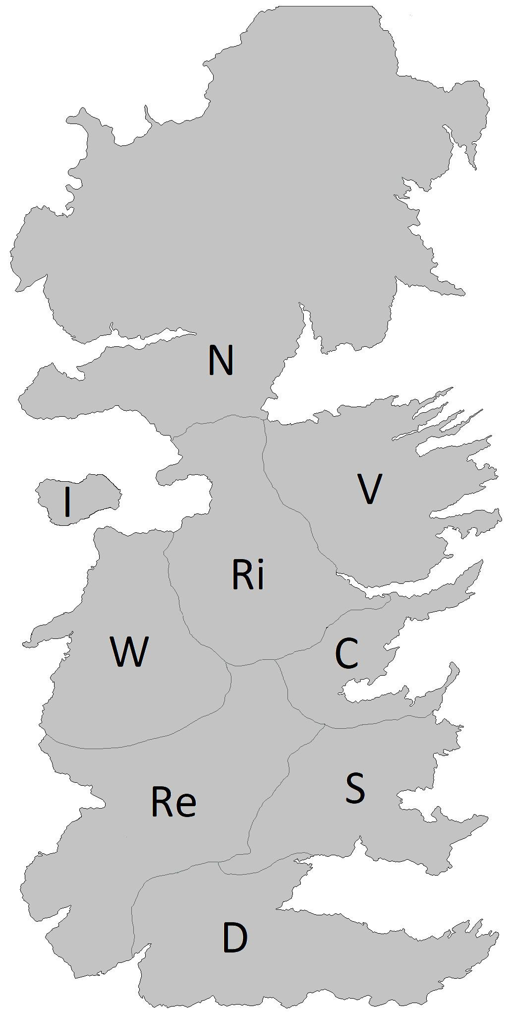

Figure 5: Map to be colored.

Part a: Draw the Constraint Graph for this problem. Can you use this information to simplify the problem?

Part b: Assuming you are using Backtracking search to solve this problem and that you are using both MRV and Degree heuristic to select the variable, Which variable will be selected at each level of the search tree [You do not need to draw the tree. Just let me know which variable will be selected and why (MRV and degree values)]. Note: Multiple possible answers. You only have to give one.

Part c: EC (10 points): Give one valid solution to this problem.

Problem 6 (Extra Credit for 4308, Required for 5360)

Max: [4308: 20 Points EC, 5360: 20 Points]

Suppose that you want to implement an algorithm tht will compete on a two-player deterministic game of perfect information. Your opponent is a supercomputer called DeepGreen. DeepGreen does not use Minimax. You are given a library function DeepGreenMove(S), that takes any state S as an argument, and returns the move that DeepGreen will choose for that state S (more precisely, DeepGreenMove (S) returns the state resulting from the opponent's move).

Write an algorithm in pseudocode (following the style of the Minimax pseudocode) that will always make an optimal decision given the knowledge we have about DeepGreen. You are free to use the library function DeepGreenMove(S) in your pseudocode. If you think regular Minimax is the answer, just state so.

4 of 5 9/14/2018, 08:42 PM

Assignment 3 https://omega.uta.edu/~gopikrishnav/classes/2018/fall/4308_5360/assmts...

5 of 5 9/14/2018, 08:42 PM

